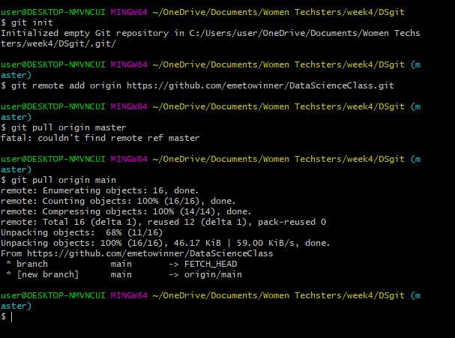

Developing Your Personal Stack

We have to Talk Practical Steps to Make Difficult Career Conversation Easier'

Art of Tooting Your Own Horn - Be Visible and Succeed